**UserInterface Design version 1**

**Software used: Visual Studio 2010 ultimate**

**C# coding:**

* Artist page
* Song page
* User page

**Data Enter in Database:**

* Artist
* Song
* User
* Rating

**C# coding for Artist Page:**

Artist page codes are given below with the screenshot.

using System;

using System.Collections.Generic;

using System.Linq;

using System.Web;

using System.Web.UI;

using System.Web.UI.WebControls;

using System.Data;

using System.Data.SqlClient;

using System.Configuration;

namespace songalbum

{

public partial class Artist : System.Web.UI.Page

{

protected void Page_Load(object sender, EventArgs e)

{

}

protected void Button1_Click(object sender, EventArgs e)

{

string constrs =ConfigurationManager.ConnectionStrings["Song_Album"].ConnectionString;

using (SqlConnection conn = new SqlConnection(constrs))

{

string sql = "INSERT INTO Artists VALUES(@ArtistName, @DOB,@Bio)";

using (SqlCommand cmd2 = new SqlCommand(sql, conn))

{

cmd2.Parameters.AddWithValue("@ArtistName",TextBox1.Text);

cmd2.Parameters.AddWithValue("@DOB",TextBox2.Text);

cmd2.Parameters.AddWithValue("@Bio", TextBox3.Text);

conn.Open();

cmd2.ExecuteNonQuery();

conn.Close();

}

Label4.Text = "Artist Details enter Successfully";

}

}

}

}

**Screenshot:**

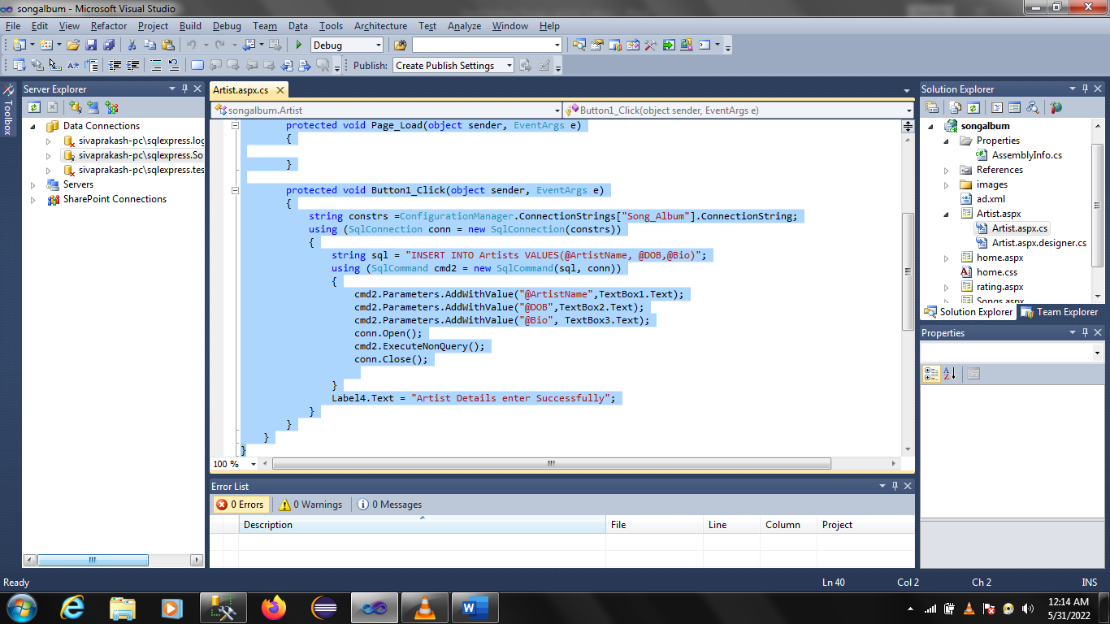

**C# coding for Song page:**

Song page codes are given below with the screenshot.

using System;

using System.Collections.Generic;

using System.Linq;

using System.Web;

using System.Web.UI;

using System.Web.UI.WebControls;

using System.Data;

using System.Data.SqlClient;

using System.Configuration;

using System.IO;

namespace songalbum

{

public partial class Songs : System.Web.UI.Page

{

protected void Page_Load(object sender, EventArgs e)

{

}

protected void Button1_Click(object sender, EventArgs e)

{

byte[] bytes;

using (BinaryReader br = new BinaryReader(FileUpload1.PostedFile.InputStream))

{

bytes = br.ReadBytes(FileUpload1.PostedFile.ContentLength);

} string constr =ConfigurationManager.ConnectionStrings["Song_Album"].ConnectionString;

using (SqlConnection conn = new SqlConnection(constr))

{

string sql = "INSERT INTO Songs(DateofRelease,cover,SongName) VALUES(@DateofRelease, @cover,@SongName)";

using (SqlCommand cmd1 = new SqlCommand(sql, conn))

{

cmd1.Parameters.AddWithValue("@SongName",TextBox1.Text);

cmd1.Parameters.AddWithValue("@DateofRelease",TextBox2.Text);

cmd1.Parameters.AddWithValue("@cover", bytes);

conn.Open();

cmd1.ExecuteNonQuery();

conn.Close();

}

Label4.Text = "Songs are Saved Successfully";

}

}

}

}

**Screenshot:**

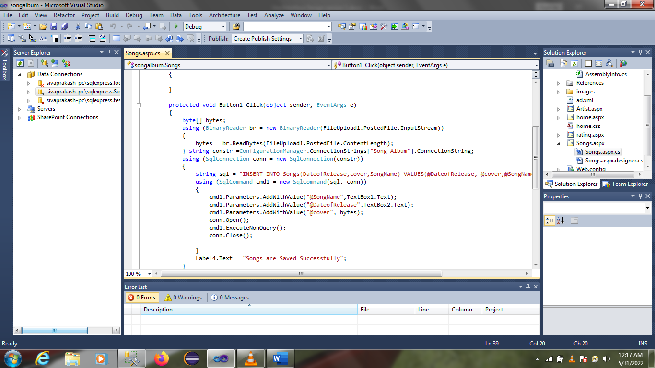

**C# coding for Rating:**

Rating page codes are given below with the screenshot.

using System;

using System.Collections.Generic;

using System.Linq;

using System.Web;

using System.Web.UI;

using System.Web.UI.WebControls;

using System.Data;

using System.Data.SqlClient;

using System.Configuration;

namespace songalbum

{

public partial class rating : System.Web.UI.Page

{

protected void Page_Load(object sender, EventArgs e)

{

if (!Page.IsPostBack)

{

SqlConnection con = new SqlConnection(@"Data Source=SIVAPRAKASH-PC\SQLEXPRESS;Initial Catalog=Song_Album;Integrated Security=True");

SqlCommand cmd = new SqlCommand("select SongName from Songs", con);

SqlDataAdapter sda = new SqlDataAdapter(cmd);

DataTable dt = new DataTable();

sda.Fill(dt);

DropDownList1.DataSource = dt;

DropDownList1.DataTextField = "SongName";

//DropDownList1.DataValueField = "Songid";

DropDownList1.DataBind();

}

}

protected void Button1_Click(object sender, EventArgs e)

{

if (Convert.ToInt32(TextBox2.Text) >= 1 && Convert.ToInt32(TextBox2.Text) <= 5)

{

string constrs = ConfigurationManager.ConnectionStrings["Song_Album"].ConnectionString;

using (SqlConnection conn = new SqlConnection(constrs))

{

string sql = "INSERT INTO Users VALUES(@UserName,@Email)";

using (SqlCommand cmd2 = new SqlCommand(sql, conn))

{

cmd2.Parameters.AddWithValue("@UserName", TextBox3.Text);

cmd2.Parameters.AddWithValue("@Email", TextBox1.Text);

conn.Open();

cmd2.ExecuteNonQuery();

conn.Close();

}

}

string constr = ConfigurationManager.ConnectionStrings["Song_Album"].ConnectionString;

using (SqlConnection con = new SqlConnection(constr))

{

string sql = "INSERT INTO Song_Rating VALUES(@UserName,@Rating,@SongName)";

using (SqlCommand cmd3 = new SqlCommand(sql, con))

{

cmd3.Parameters.AddWithValue("@UserName", TextBox3.Text);

cmd3.Parameters.AddWithValue("@Rating", TextBox2.Text);

cmd3.Parameters.AddWithValue("@SongName", DropDownList1.Text);

con.Open();

cmd3.ExecuteNonQuery();

con.Close();

Label4.Text = "rating has been done successfully ";

}

}

}

else

{

Label4.Text = "enter valid rating";

}

}

}

}

**Screenshot:**

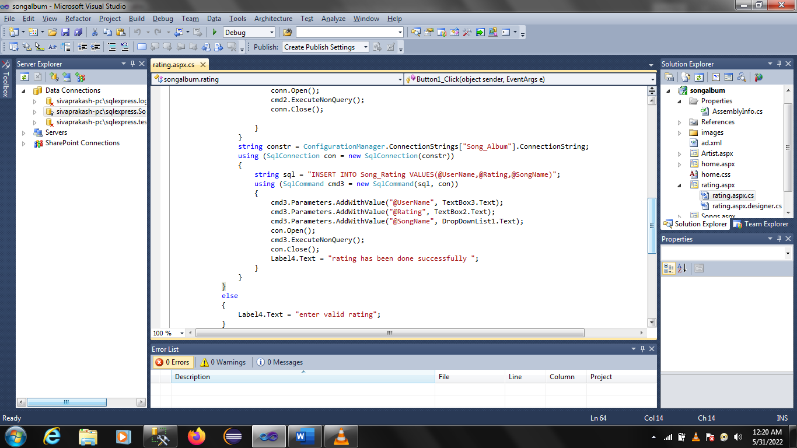

**Data Enter in Database:**

**Artists**

Data enter in Database for Artist.

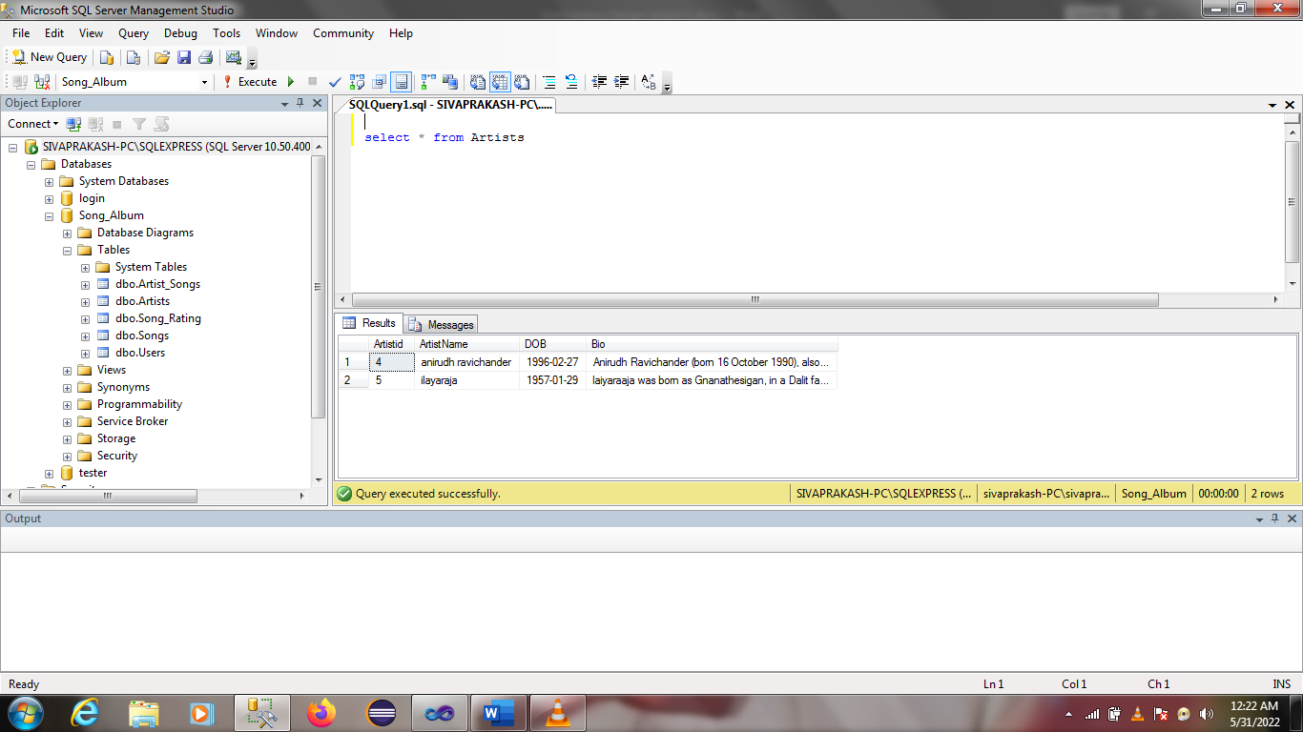

**Songs:**

Data enter in Database for Songs.

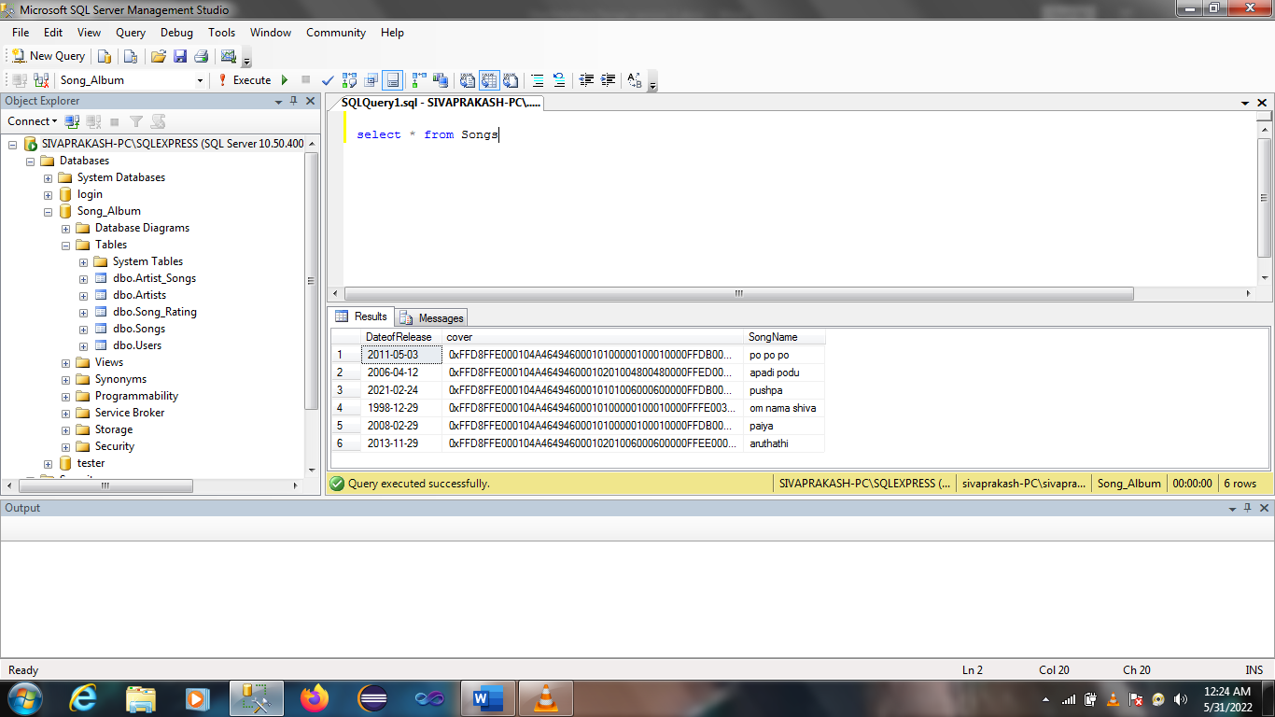

**Users:**

Data enter in Database for Users.

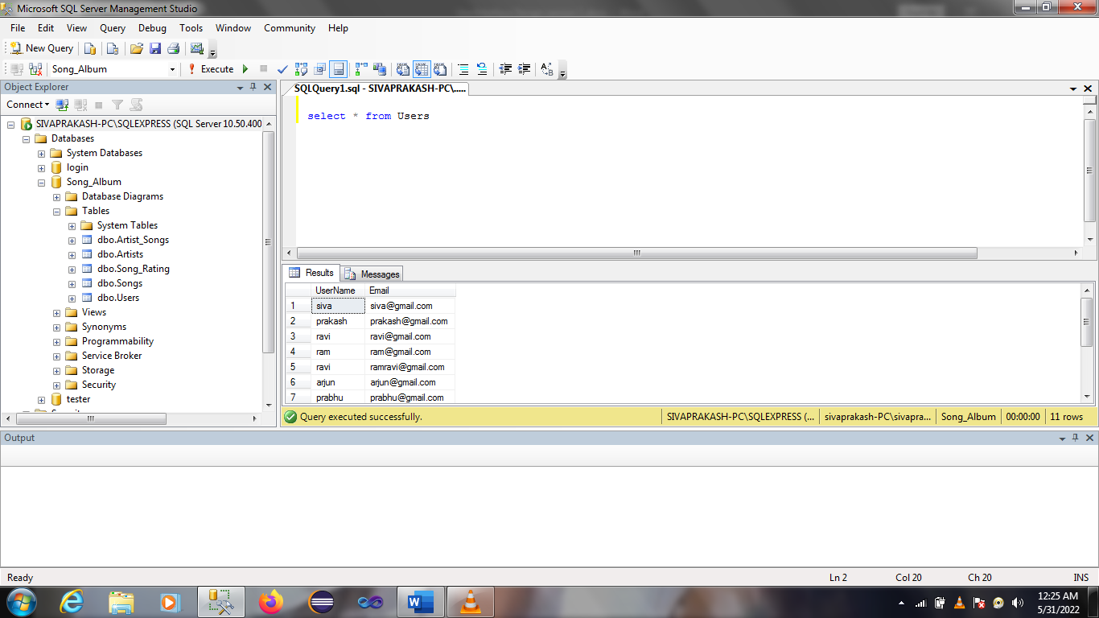

Song_Rating:

